 | The CAMECA IMS 7f auto, 7f, 4fE7(*)  Scan all user’s guide  00 45 610 xxx - Type 108 – Indice A
0000.doc
.
Index

Contents
The Scan all Principles 2
1. Scan all: 5
1.1 Single: 5
1.2 X&Y parameters: 8
1.3 Align: 10
1.4 The CCD Tool menu : 12
2. Fcp: 13
2.1 FCp Test parameters 16
2.2 FCp measurement links with the Setup file 17
3. FCs Measurement 17
3.1 Overview 17
4. EM: 22
4.1 Overview 22
4.2 The EM Measurement Box: 23
4.3 The EM measurement parameters box 24
4.4 Links with the Setup file 25
4.5 The EM Yield 26
4.5.1 Overview 26
4.5.2 The EM Yield main box 27
4.5.3 The EM Yield parameter box 27
4.5.4 Links with the Setup file 28
4.5.5 The EM PHA 28
4.5.6 Overview 28
4.5.7 The EM PHA main box 29
4.5.8 The EM PHA Measurement Parameters Box 30
4.5.9 Links with the Setup file 30
4.6 The EM HV routine 31
4.6.1 Overview 31
4.6.2 EM HV links with the Setup file 33
5. Apertures: 34
5.1 Contrast aperture: 34
5.2 Field aperture: 35

Contents ↑

The Scan all Principles

The Scan all routine allows to select any instrument parameter for full or dedicate scan range in order to record a curve using any detector, It is also possible to compute the centre of the curve and to set automatically the parameter to the value corresponding to this centre.
A cursor can be use on the graphic display, to select the optimized parameter value which is automatically saved in the ISF files after validation.
The acquisition can be record either using the primary faraday cup or the secondary detectors. Although this program can be used to record the primary or secondary beam stabilities.

The program main window is shown below.

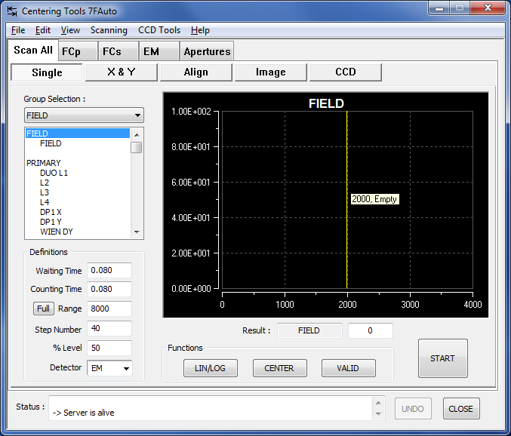

The upper tool bar displays 6 different menus: File, Edit, view, CCD Tool and Help.

The file menu:
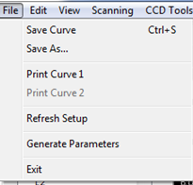

- Save Curve: Allows to save the current curve under .txt format file. The file is directly store in the plot directory.
- Save as: To store the current curve under .txt format in another directory with a dedicate name.
- Print curve 1: To print the curve as show in the scan all window.
- Refresh setup: Used to update values from the setup file.
- Generate parameters: Allows to generate new parameters by default.

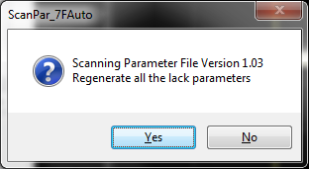

- Exit: To exit the file menu.

The Edit menu:

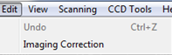

- Imaging correction:

From one instrument to another one, some parameters values may have slight differences. To be able to standardize all instruments a coefficient can be loaded during the test at the factory.

These parameters must not be change by customer without official CAMECA FSE agreement.

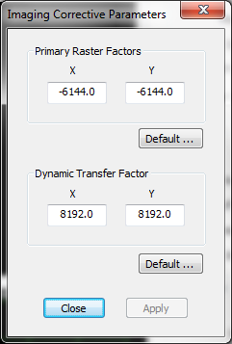

- Primary Raster Factors : Raster coeficient for primary beam depending on the instrument ( factory adjustment)

- Dynamic Transfer Factor: Raster coeficient for secondary beam depending on the instrument ( factory adjustment)

Default value:

The view menu :

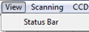

- Status Bar: To display extra parameters in the lower tool bar.

The Scanning menu :
The scanning menu present the same fonctions as the scann all fonctions.

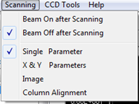

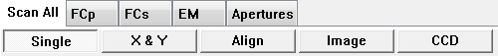

Two options can be setup for the primary beam status.
- Beam on after Scanning: Leave the primary beam on, even after the last scan.
- Beam off after Scanning: Turn off the primary beam after the last scan.

Scan all:
Five different action can be selected:

- Single: To scan one parameter at a time and valid the optimized value using the cursor position in automatic or manual mode.
- X & Y: to scan two parameter a time, generally in X and Y direction.
- Align: this feature can be use to align correctly on column parameter.
- Image:….
- CCD: ….

Selection of the target parameter is done trough the left window ‘group selection’.

Single:
The single parameter is generally used to scan a lens, the field etc.

All instrument parameters are divides under 5 groups:

Field, Primary, Secondary, E-gun, Apertures & Slits.

Selection of the detector will automatically turn on or off the primary beam. The cursor can be place manually (using the right mouse button and drag the cursor to the selected value) or, using the center button witch will automatically set to the middle position defined by the % Level. The valid button transfers the new value to the tuning program.

Using the full range button allowed to scan the complete parameter range, or a part of it if defined in the range window.

The step number allowed getting better definition of the scan curve.

The % Level defines the limit of the measurement intensity.

Selection of the measurment detector.

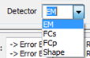

- EM: Secondary electron multiplier detector (note that the maximum counting rate should remain under 1E6 counts/seconde).
- FCs: Secondary faraday cup detector.
- FCp: Primary faraday cup.
- Shape: Not available.

- The following table shows the different single parameters witch can be scan.

 | Scan parameters | With the beam on | With the beam off
Field | Field | x
Primary | Duo L1 |  | x
 | Wl |  | x
 | L2 |  | x
 | L3 |  | x
 | Wien DY |  | x
 | DP1x |  | x
 | DP1y |  | x
 | DP-WLx |  | x
 | DP-WLy |  | x
 | DP3a-x |  | x
 | DP3a-y |  | x
 | DP3b-x |  | x
 | DP3b-y |  | x
 | DP-4-x |  | x
 | DP-4-y |  | x
 | Stig-45 | x
 | Stig-90 | x
 | Beam pos x | x
 | Beam pos y | x
Secondary | limm | x
 | Stig-x | x
 | Stig-y | x
 | Ltr1 | x
 | Dtfa-x | x
 | Dtfa-y | x
 | Ltr2 | x
 | Dtca-x | x
 | Dtca-y | x
 | ESA | x
 | Lcoup | x
 | HC3 | x
 | DC2D-x | x
 | DC2D-y | x
 | DPR-x | x
 | DPR-y | x
 | IMStig-x | x
 | IMStig-y | x
 | LPR1 | x
 | LPR2 | x
 | Exit ESA | x
 | EMD-y | x
 | FCD-y | x
 | FCS-REP | x
 | MCP-x | x
 | MCP-y | x
 | EM-Threshold | x
NEG | Lens e⁻ | x
 | Quad e⁻ | x
 | Def1-x-e⁻ | x
 | Def1-y-e⁻ | x
 | Def2-x-e⁻
 | Def2-y-e⁻
 | Bxe⁻
 | Bye⁻
APER & SLITS | D0-x | x
 | D0-y | x
 | D4-x | x
 | D4-y | x
 | CA APER-x | x
 | CA APER-y | x
 | FA APER-x | x
 | FA APER-y | x
 | ENT SL-x | x
 | ENT SL-w | x
 | ENR SL-x | x
 | ENR SL-w | x
 | EXIT SL-w | x

X&Y parameters:
Is used to scan deflectors or stigmators in both, X and Y directions.

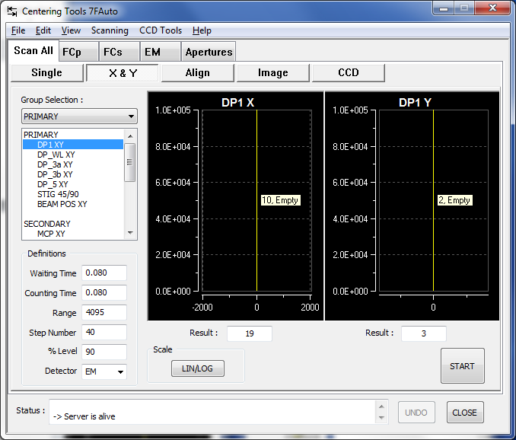

Procedure to select primary or secondary detectors is the same as for Single scan option.

- The following table shows the different X & Y parameters witch can be scan.

 | Scan parameters | With the beam on | With the beam off
Primary | DP1x&y |  | x
 | DP-WLx&y |  | x
 | DP3a-x&y |  | x
 | DP3b-x&y |  | x
 | DP-4-x&y
 | Beam pos x&y | x
 | Stig-x&y | x
Secondary | Dtfa-x&y | x
 | Dtca-x&y | x
 | DC2D-x&y | x
 | DPR-x&y | x
 | IMStig-x&y | x
 | MCP-x&y | x
NEG | Def1-x&y-e-
 | Def2-x&y-e-
APER & SLITS | D0-x&y | x
 | D4-x&y | x
 | CA APER-x&y | x
 | FA APER-x&y | x
 | FA APER-y | x
 | ENT SL-x&y | x
 | ENR SL-x&w | x

Align:
Column alignment: Several parameters can be use to improve the beam alignment.

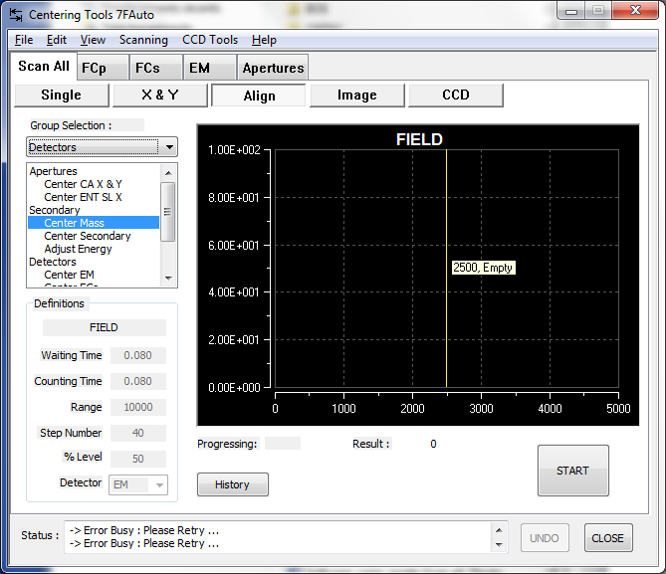

- The following table shows the different Align parameters witch can be scan.

Apertures | Center CA x & y | x
 | Center FA x & y | x
Sacondary | Center Mass | x
 | Center secondary | x
 | Center energy | x
Detectors | Center EM | x
 | Center FCs | x
 | Adjust Fcs offset |  | x
 | Adjust EM HV | x
 | Adjust EM Tield | x

Image: This menu allowed to center the beam using Beam pos X&Y for the primary beam and the DTFA X&Y for the secondary beam.

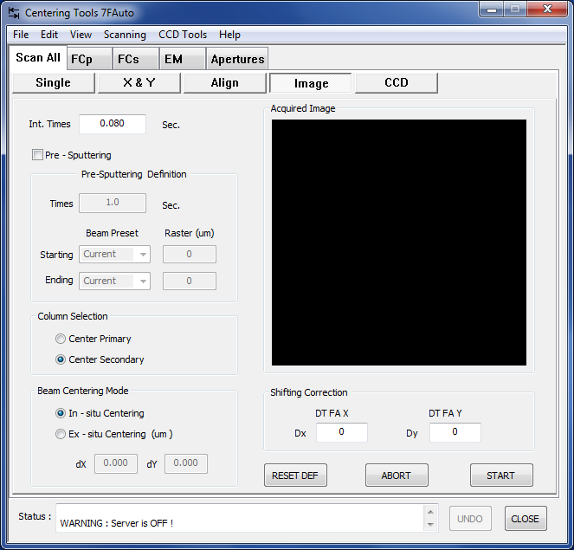

Several parameters can be setup for the acquisition :

- Integration time.
- Pre-sputtering: sputter the sample surface with the primary beam during a a pre sputtering time definition befire starting the measurement.
- Column selection: Choice between primary and secondary beam centering.
- Beam centering mode: In situ centering will be performd at the actual sample position, Ex-situ the stage will move to an ather position defined by the dx and dy parameters.

The CCD Tool menu :

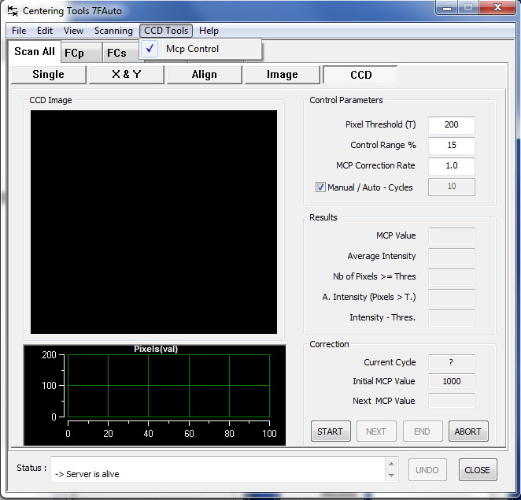

- Pixel threshold :
- Control range :
- MCP correction rate :
- Manual/auto-Cycles :

Fcp:
This tool is targeted to the measurement of the primary ion current. The primary current is measured with a Faraday cup device, Fcp, quite similar to the secondary Faraday cup, Fcs, described in the ion optics user's guide. A pair of Beam_Blanking plates (BBP) allow to deflect the primary beam into the Fcp Faraday cup. The BBP deflection amplitude is tuned for each ISF (See the Tuning software user's guide)
The primary ion beam current can be measured either with the Static Mode or with the Sampled Mode. As it is explained in the ion optics user's guide, the Sampled Mode allows to record the primary beam intensity while keeping it working, by sampling the beam along the time towards a Faraday Cup.
With the Static Mode, the beam is more conventionally deflected permanently into the Faraday cup.

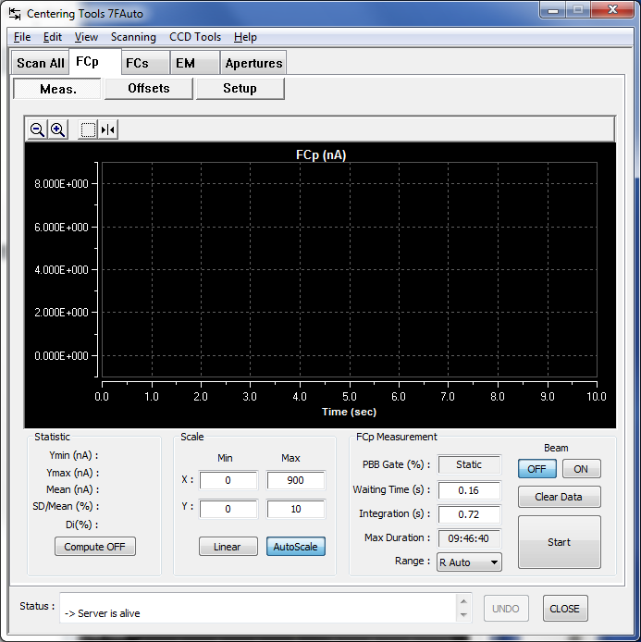

- BBP-gate (%) displays the sampling rate, as it is defined in the ion optics user's guide , i.e. the time percentage during which the beam is deflected into the Fcp Faraday cup. BBP_gate is actually edited in the Measurement parameters box.
- Integration time. Is displayed both in second (Sec=) or in number of 80 ms frames (Ntrame=) . Both are dependent, according to the relationship
- sec = Nframe * 80 ms
The current measured will be averaged among the Nframe frames and displayed in the Fcp Intensity field. Nframe is edited in the Measurement parameter box.

- Max Duration: Pre define the total time range range for the measurement.
- Scale of the intensity measurement can be define manually or in automatic mode, a,d curve display in linear or logarithmic scale.

How to determine the FCp offset?
Manually
- Get a zero primary current, by setting the primary beam outside the Faraday cup, i.e. by keeping it on-axis (BEAM ON).

Be sure to remove the beam sampling measurement option before in the synoptic window.
- Select the range value.
- Read the FCp signal in the FCp Intensity display field.
- Copy this value in the offset measurement box field corresponding to the current polarity and the current FCp range.

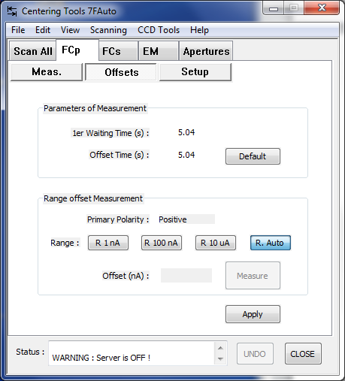

FCp Test parameters
- 1st Wait Time (s) is the delay between the BEAM ON command which drives the primary current out of the Faraday cup and the beginning of the FCp measurement. (typ. 2 sec) (Setup # 342)
- Offset Time (s) determines the number of frames averaged for the FCp offset measurement. (typ. 2 sec) (Setup # 345)
- Apply writes in the Setup file the FCp Test Parameters box modified parameters and closes the box

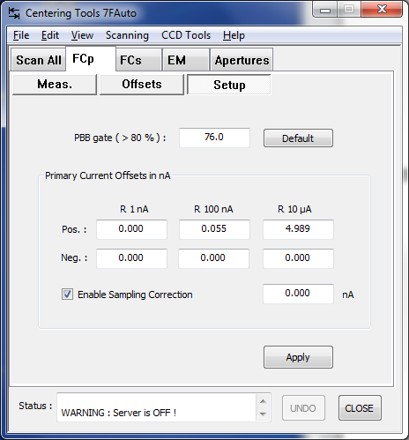

The setup windows resume the complete primary faraday cup offset measurement for all the ranges.

The enable Sampling correction option apply or not the offset correction.

FCp measurement links with the Setup file
FCp measurement parameters
# | Set-up Label | Comments
24 | Integrat time for the Prim Cur | (FCp Measurement)
315 | FCP_MODE_VAL | Fcp Mode (Static/Sampled)
318 | FCP_RANGE_VAL | Fcp measurement range (10µA/100nA/1nA)
321 | FCP_NLINE_BBP_ON_VAL | Depends on the sampling rate as  511(1-100*(BBP_gate%))
324 | FCP_OFFSET_R1_POS_VAL | Positive Primary Range=10µA Faraday offset
327 | FCP_OFFSET_R2_POS_VAL | Positive Primary Range=100nA Faraday offset
330 | FCP_OFFSET_R3_POS_VAL | Positive Primary Range=1nA Faraday offset
333 | FCP_OFFSET_R1_NEG_VAL | Negative Primary Range=10µA Faraday offset
336 | FCP_OFFSET_R2_NEG_VAL | Negative Primary Range=100nA Faraday offset
339 | FCP_OFFSET_R3_NEG_VAL | Negative Primary Range=1nA Faraday offset
496 | Primary Faraday Cup offset correction | (0/1)
497 | Primary Faraday Auto-range flag | (0/1)

Additionnal FCp test parameters
# | Set-up Label | Comments
342 | FCP_TEST_WAIT_TIME_VAL | (FCp Offset Test Tool)
345 | FCP_TEST_OFFSET_TIME_VAL | (FCp Offset Test Tool)
348 | FCP_TEST_BBP_ON_TIME_VAL | (FCp Offset Test Tool)
351 | FCP_TEST_BBP_OFF_TIME_VAL | (FCp Offset Test Tool)

FCs Measurement

Overview
This tool is targeted to the measurement of the secondary ion current with the Faraday Cup (FCs). For the description of the Faraday Cup device, see the ion optics user's guide.
For obtaining a FCs signal, it is necessary to switch the beam towards the FCs device, by clicking FC on the Tuning main bar.

- Measurement : clicking this button opens the editing box Measurement. The box is opened with the parameter values as they are in the setup file.

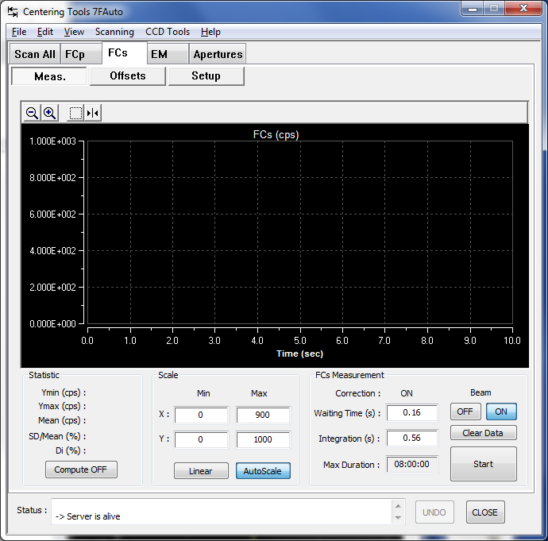

- Integration time. Is displayed both in second (Sec=) or in number of 80 ms frames (Ntrame=) . Both are dependent, according to the relationship
- sec = Nframe * 80 ms
The FCs signal is averaged over the Nframe frames and displayed in the FCs Intensity field. Nframe is edited in the FCs Measurement parameter box.

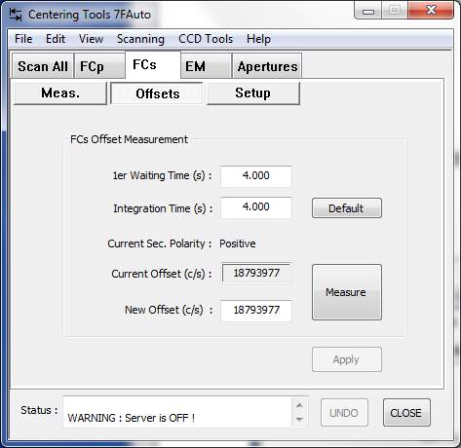

- 1st Wait Time (s) is the delay between the BBS ON command which drives the secondary current out of the Faraday cup and the beginning of the FCp measurement. (typ. 2 sec) (Setup # 390)

- Integration time. Is displayed both in second (Sec=) or in number of 80 ms frames (Ntrame=) . Both are dependent, according to the relationship
- sec = Nframe * 80 ms

- offsets : clicking this button opens the editing box Measurement Parameters. The box is opened with the parameter values as they are in the setup file.
The FCs signal is averaged over the Nframe frames and displayed in the FCs Intensity field. Nframe is edited in the FCs Measurement parameter box.

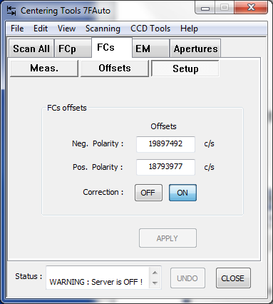

- correction (ON/OFF), switching button for enabling/disabling the FCs offset correction. The same selection is valid for Tuning (Real Time screen) and for the analyses (exept for image analysis) but not for Mass Calibration. The FCs offset can be edited in the FCs Measurement parameter box. (Setup #517)

How to determine the FCs offset ?
Manually
  - Get a zero secondary signal, by blanking either the primary beam (BEAM OFF) or the secondary beam (BBS ON).
  - Read the FCs signal in the FCs Intensity display field.
  - Copy this value in the Measurement Parameters box field corresponding to the correct polarity.
Automatically
  - Use the FCs offset routine (see below the section § The FCs offset routine)
  - FCs links with the Setup file

FCs Measurement parameters
# | Set-up Label | Comments
44 | Integrat time for the Sec current | (FCs Measurement tool)
387 | FCs Offset (pos. polarity) value | (FCs Measurement tool, FCs Test tool, Tuning, Analyses)
501 | Optical gate flag | (0/1) (EM & FCs Measurement tool)
513 | E-Gate norm. flag | (0/1) (EM & FCs Measurement tool, EM PHA tool)
515 | BBS flag | (0/1) must be always to 0 except in EM & FCs Measurement tool.
517 | FCS corr. flag | (0/1) (FCs Measurement tool, Tuning, Analyses)
607 | FCs Offset (neg polarity) value | (FCs Measurement tool, FCs Test tool, Tuning, Analyses)

FCs test parameters
# | Set-up Label | Comments
390 | FCS_FIRST_WAITING_TIME_VAL | ( FCs Test tool)
393 | FCS_OFFSET_TIME_VAL | ( FCs Test tool)
396 | FCS_BBS_ON_TIME_VAL | ( FCs Test tool)
399 | FCS_BBS_OFF_TIME_VAL | ( FCs Test tool)

Additionnal FCs parameters involved in Analysis
# | Set-up Label | Comments
517 | FCS corr. flag | (FCs Measurement tool, Tuning, Analyses)
535 | prec | precision (%) parameter (Depth Profile Analysis)
539 | FCs integration status (0/1) | if 1, the data reduction program shift the FCs frames.  if 0, the FCs frames are processed as for the EM frames (Depth Profile Analysis)
540 | Tfr | frame time (s)  (Depth Profile Analysis)
541 | Tfcs | FCs response time (s)  (Depth Profile Analysis)
542 | Tfcp | Tfcp response time (s)  (Depth Profile Analysis)

EM:

Overview
This tool is targeted to the measurement of the secondary electron multiplier (EM) signal. See the EM physical model in the ion optics user's guide § Electron multiplier (EM). It is useful to check the EM corrections which are normally involved in the analysis.
The EM Tool must also be used for checking the secondary beam-blanking (BBS) in a static mode while it is used in the other applications for achieving the electron gating. See the ion optics guide § Electronic gating.
For obtaining an EM signal, it is necessary to switch the beam towards the EM device, by clicling EM on the Tuning main bar.

The EM Measurement Box:

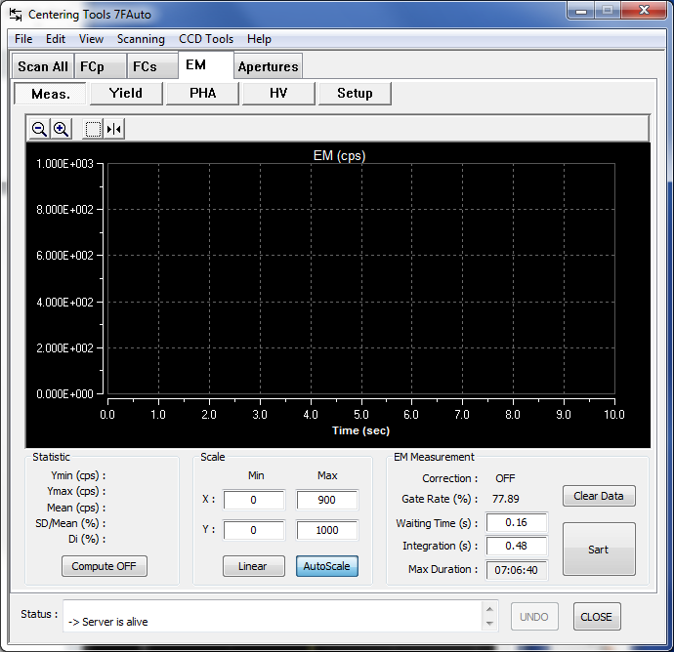

- Measurement parameters : clicking this button opens the editing box Measurement Parameters. The box is opened with the parameter values as they are in the setup file.
- Integration time. Is displayed both in second (Sec=) or in number of 80 ms frames (Ntrame=) . Both are dependent, according to the relationship
sec = Nframe * 80 ms
The EM counts are counted over the Nframe frames and displayed in the EM Intensity field. Nframe is edited in the Measurement parameter box.
- EM Intensity (c/s) displays the EM count rate, averaged over Nframe frames.
- Scope ON/OFF, switching button for opening and closing the Oscilloscope box.
- Detection correction (ON/OFF), switching button for enabling/disabling the EM correction (defined by the Yield Y_{EM}, the dead time τ and the Background rate Bkg defined in the Measurement parameters box) according to the formula
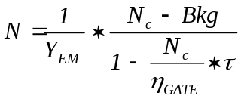
η_{GATE} is defined in the ion optics user's guide § Dead time corrections dependance on the gating (Setup #514)
The same selection is valid for the analyses (exept for image analysis) but not for Mass Calibration and Tuning.
- BBS (ON/OFF) Selecting BBS ON allows to set the secondary Beam-Blanking in a static mode. Especially purposed to tune the BBS amplitude, in cooperation with the Tuning synoptics. (Setup #515)
- E-gate normalization (ON/OFF) normalizes the displayed EM intensity to the 100% gate i.e. divides the intensity by the gate rate η_{GATE} . This normalized signal is not expected to depend on the gating (Setup #513)
- Optical gate (ON/OFF) Selecting Optical gate ON leads to take into account the case Optical gate in the calculation of η_{GATE}. (Setup #501)
- Gate rate (%) displays η_{GATE}I. (Setup #261)

The EM measurement parameters box
- Nframe edits the number of 80 ms frames which define the acquisition integration time - (Setup #44)
- Yield(%) edits the Yield Y_{EM} used in the EM correction formula. (Setup #34)
- Deadtime (ns) edits the deadtime τ used in the EM correction formula. (Setup #258)
- Background (c/s) edits the background rate Bkg. (Setup #33)
- 100% Threshold (mV) edits the current EM threshold value used in the EM HV Test (See below the section § The EM HV Test). (Setup #261)
- 50% Threshold (mV) edits the EM threshold used in the EM HV Test (See below the section § The EM HV Test). (Setup #264)
- EM HV (V) edits the EM High Voltage which can be also set by hand in the Tuning synoptics or automatically set by the The EM HV Test. (Setup #37)
- Optical gate diameter (µm) displays the optical gate diameter value, i.e. the selected Field Aperture (FA) diameter. The optical gate diameter is taken into account in the η_{GATE} calculation.
- Apply writes in the Setup file the Measurement Parameters box modified parameters and closes the box
- Cancel closes the box without writing in the setup file the box modified values.
Contents ↑

Links with the Setup file

# | Set-up Label | Comments
33 | EM Background | (EM Measurement tool, analyses)
37 | EM HV | EM High Voltage
34 | EM Detection efficiency | EM Yield (EM Measurement tool, analyses)
44 | Integration time for the Secondary current | (EM Measurement tool)
258 | EM_DEAD_TIME_VAL | EM dead time (EM Measurement tool, analyses)
261 | EM_THR_100_VAL | See EM HV Test. Expected to be the current EM Threshold (Setup #36)
264 | EM_THR_50_VAL | See EM HV Test
501 | Optical gate flag | (0/1) (EM & FCs Measurement tool, Analyses)
513 | E-Gate norm. flag | (0/1) (EM & FCs Measurement tool, EM PHA tool)
514 | EM corr. flag | (0/1) (EM Measurement tool, EM PHA tool, Analyses)
515 | BBS flag | (0/1) must be always to 0 except in EM & FCs Measurement tool.

Contents ↑

The EM Yield

Overview
The Yield target is to launch a test routine purposed for measuring automatically the EM Yield and for writing the result in the setup file. See the EM physical model and the meaning of the EM Yield in the ion optics user's guide § Electron multiplier (EM) .
The routine achieves a procedure consisting in measuring the same signal successively with the FCs Faraday channel and with the EM channel. As the FCs measurement is supposed to be 100% of the signal, it is therefore straight to deduce the EM yield as the ratio EM/FC.

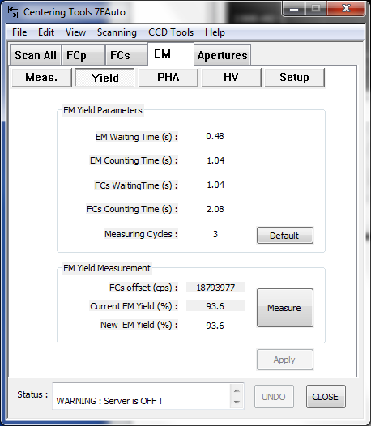

The EM Yield Sketch (one cycle time diagram)

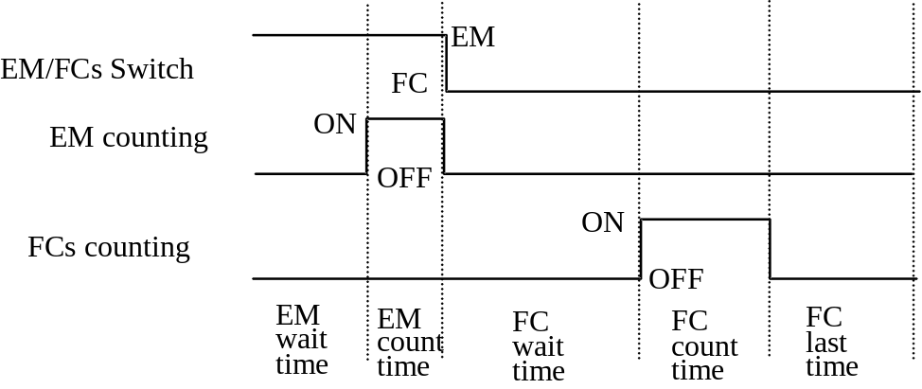

The EM Yield main box
- Measurement parameters: clicking this button opens the editing box Measurement Parameters. The box is opened with the parameter values as they are in the setup file.
- Mode (Auto/Manual) With Auto the routine will be launched with START, and the result will be automatically wrote in the setup file. With Manual, the routine will be also launched with START, but the operator will be asked to validate the result for writing it in the setup file.
- START/STOP Starts and stops the EM Yield routine. The routine is performed with the setup parameters which can be edited in the measurement box.
- EM Yield displays the EM yield as it is in the setup file or as it results from the EM Yield routine. Note that the EM yield can be edited in the EM Measurement parameter box. (Setup #34)
- Valid, button to be pressed in the Manual mode for writing the EM Yield routine result in the setup file.
- Close

The EM Yield parameter box
- Nb of cycles edits the number of EM/FC cycles which will be repeated within the EM Yield routine. (Setup #270)
- EM wait time (s) edits the waiting time displayed in the EM Yield sketch. (typ. 0.5 sec) (Setup #273)
- EM count time (s) edits the counting time displayed in the EM Yield sketch. (typ.1sec) (Setup #276)
- FC wait time (s) edits the waiting time displayed in the EM Yield sketch. (typ. 1 sec) (Setup #279)
- FC count time (s) edits the counting time displayed in the EM Yield sketch. (typ. 0.5 sec) (Setup #282)
- FC last time (s) edits the last time displayed in the EM Yield sketch. (typ. 0.5 sec) (Setup #285)
- Apply writes in the Setup file the Measurement Parameters box modified parameters and closes the box
- Cancel closes the box without writing in the setup file the box modified values.

Links with the Setup file
# | Set-up Label | Comments
34 | EM Detection efficiency | EM Yield (EM Measurement, depth profile)
270 | EM_YIELD_NB_CYCLE_VAL | Number of EM/FC cycles repeated in the EM Yield tool.
273 | EM_YIELD_WAIT_TIME_VAL | EM Yield tool timing parameter
276 | EM_YIELD_COUNT_TIME_VAL | EM Yield tool timing parameter
279 | EM_YIELD_FC_WAIT_TIME_VAL | EM Yield tool timing parameter
282 | EM_YIELD_FC_COUNT_TIME_VAL | EM Yield tool timing parameter
285 | EM_YIELD_LAST_TIME_VAL | EM Yield tool timing parameter

The EM PHA

Overview
The PHA tool is purposed to display the PHA distribution curve. PHA states as "Pulse Height Amplitude". The PHA curve allows the operator to check the Electron Multiplier (EM) aging, and to decide a possible EM HV increase. The involved physical principles are presented in the ion optics user's guide § Electron multiplier (EM) . As it is explained in this last user's guide, it is recommended to keep the EM Threshold constant and to play only with the EM HV for keeping the same PHA curve template all along the EM lifetime. EM HV automatic tuning is made possible with the EM HV routine (see below).

The PHA routine is basically a scan-acquisition, where EM Threshold is the scanned parameter and the EM counts the acquired signal.

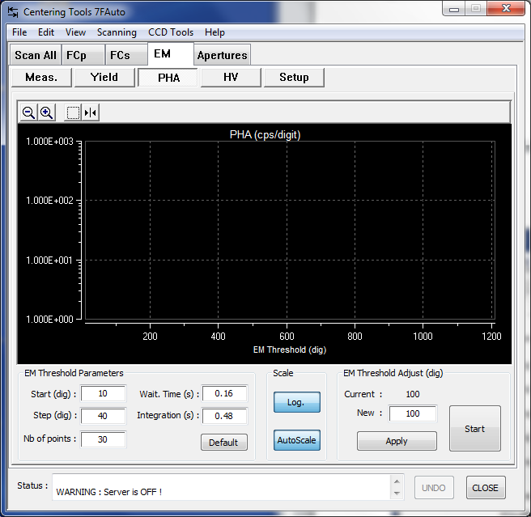

- The total scan lengh is defined by the step range and the number of steps.
- The display scales can be enter manualy or using the autoscale.
- The Em theshold adjustment can be modified in the new area and validate with the apply button.

- This icone display a cursor witch can be use to select the threshold value directly on the grafic.

- These icone are used to zoom or unzoom the grafic display.

The EM PHA main box
- Measurement parameters : clicking this button opens the editing box Measurement Parameters. The box is opened with the parameter values as they are in the setup file.
- Integration time displays the time or the number of frames corresponding to the acquisition before starting a PHA curve acquisition. This parameter is edited in the EM Measurement/Measurement parameters box (Setup #44).
- EM intensity (c/s) displays the EM signal before starting a PHA curve acquisition.
- detection correction (ON/OFF) switching button for enabling/disabling the EM correction. See above the section § EM Measurement tool. It is recommended to set it to OFF for the PHA curve acquisition. (Setup #514)
- E-gate normalization (ON/OFF) normalizes the displayed EM intensity to the 100% gate i.e. divides the intensity by the gate rate η_{GATE} . See above the section § EM Measurement tool. It is recommended to set it to OFF for the PHA curve acquisition (Setup #513)

The EM PHA Measurement Parameters Box
- Start Voltage (mV) edits the initial EM Threshold of the PHA scan-aquisition routine. (Setup #288)
- Step Voltage (mV) edits the EM Threshold step of the PHA scan-aquisition routine. (Setup #291)
- Nb of points edits the number of points of the PHA scan-aquisition routine. (Setup #294)
- Waiting time (s) edits the time between 2 points of the PHA scan-aquisition routine. (Setup #297)
- Count time (s) edits the EM counting time for each point of the PHA scan-aquisition routine. (Setup #300)
- Apply closes the EM PHA Parameters box and writes the edited parameters in the setup file.
- Cancel closes the EM PHA Parameters box without writing the edited parameters in the setup file.

- START/STOP Starts or stops the PHA curve acquisition. START opens the PHA curve box containing agraphical window. See below the section § The EM PHA curve box.
- close returns to the main Tool pad while closing the PHA box.

Links with the Setup file
# | Set-up Label | Comments
36 | EM Threshold | ( EM PHA tool, Tuning)
288 | EM_PHA_START_VOLTAGE_VAL | ( EM PHA tool)
291 | EM_PHA_STEP_VOLTAGE_VAL | ( EM PHA tool)
294 | EM_PHA_NB_POINTS_VAL | ( EM PHA tool)
297 | EM_PHA_WAIT_TIME_VAL | ( EM PHA tool)
300 | EM_PHA_COUNT_TIME_VAL | (EM PHA tool)
513 | E-Gate norm. flag | (0/1) (EM Measurement tool, EM PHA tool)
514 | EM corr. flag | (0/1) (EM Measurement tool, EM PHA tool)

The EM HV routine

Overview
As it is explained in the ion optics user's guide § Electron multiplier (EM), when an EM is used, there is an aging phenomenon consisting in a gain decrease and requiring therefore to increase the EM High Voltage (EM HV) all along the EM life, for compensating the aging.
The EM HV routine is purposed to re-adjust automatically EM HV. EM HV is set to keep the PHA curve within a given template featured by a couple of value (Thresh(100%), Thresh(50%)). Practically, the routine does not process the PHA curve, but it just set EM HV so that when setting the EM discriminator threshold to Thresh(50%), the signal is the half of this corresponding to Thresh(100%). Note that the Thresh(100%) value is typically the same that the working threshold, normally kept fixed all along the EM life

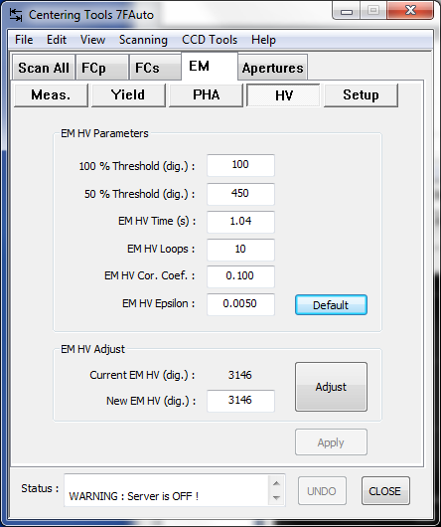

The EM HV Adjust routine main box
- Measurement parameters : clicking this button opens the editing box Measurement Parameters. The box is opened with the parameter values as they are in the setup file.
- EM HV adjust (START/STOP) Starts or stops the test
- EM_HV displays the EM HV value all along the routine completion. (Setup # 37)
- Loop nb displays the number of the routine loop in progress.
- Delta displays δ which must be smaller and smaller if the routine is converging (See below the definition of δ)
- Close closes the box

The EM HV Adjust routine parameter box
- 100% Thr (digits) edits Threshold(100%), the reference threshold value normally close to the working threshold value. (typ 70) (Setup # 261)
- 50% Thr (digits) edits Threshold(50%), which set the EM signal at the half of the amplitude obtained when the threshold is set at Threshold (100%). (typ 350) (Setup # 264)
- EM HV Time (s) edits the step counting time, corresponding to Threshold(100%) or Threshold(50%) as well (typ. 1 s.) (Setup # 303)
- Coeff_test_EMHV edits the routine feedback coefficient k. At each routine step, EM HV is readjusted accordingly to
EMHV_{NEW} = EMHV_{OLD} * k *δ
with 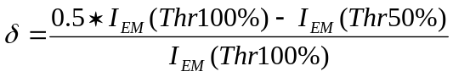
I_{EM}(Thr100%) and I_{EM}(Thr50%) being the EM signal obtained with the EM threshold set at Thr100% and Thr50%.
(typ 0.1) (Setup # 306)
- EMHV_nbloop edits the routine maximum number of loop. (typ. 10) (Setup # 309)
- EMHV Epsilon edits the routine convergence test coefficient which is compared to δ (typ 0.005) (Setup # 312)
- Apply writes in the Setup file the Measurement Parameters box modified parameters and closes the box
- Cancel closes the box without writing in the setup file the box modified values.

EM HV links with the Setup file

# | Set-up Label | Comments
37 | EM HV | ( EM Measurement tool, EM HV tool, Tuning)
261 | EM_THR_100_VAL | ( EM HV tool)
264 | EM_THR_50_VAL | ( EM HV tool)
303 | EM_HV_COUNT_TIME_VAL | ( EM HV tool)
306 | EM_HV_COEF_TEST_VAL | ( EM HV tool)
309 | EM_HV_NB_LOOP_VAL | ( EM HV tool)
312 | EM_HV_EPSILON_VAL | ( EM HV tool)

Contents ↑

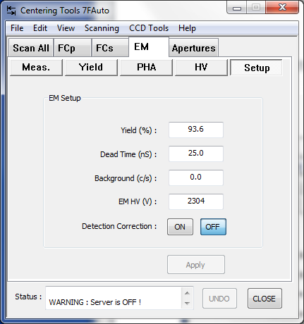

The Em Setup resume the different parameters relatives to the EM. These values are stored in the setup file.

# | Set-up Label | Comments
33 | EM Background | Generally 0
34 | EM Detection efficiency | Depending on the EM yield measurement
35 | EM Dead time | 25ns
36 | EM Theshold
37 | EM HV
38 | EM P.A.HV

Em detection correction on/of button is used to activate the parameters correction or not.
Undo function allowed to recall old values from the setup file.

Apertures:

Contrast aperture:

The IMS 7f includes 4 different contrast apertures. The position of the largest one is considered as the reference one.

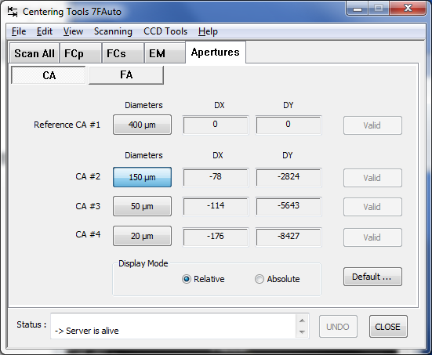

The apertures windows routine allowed to preset the correct position of each aperture. This preset coordinates are not stored in the ISF files but in the setup file after validation.

Two modes can be selected:

- Relative position: The relative position for each aperture, is the position ofset compare to the reference one. To store this values use the X and Y wheels, adjust position and valid it. The relative coordinate are stored in the setup file ‘cur_stpv3.set’.

# | Set-up Label | value
827 | CA#1DX | 0
828 | CA#1DY | 0
829 | CA#2DX | -78
830 | CA#2DY | -2824
831 | CA#3DX | -114
832 | CA#3DY | -5643
833 | CA#4DX | -176
834 | CA#4DY | -8427

- Absolute position: X and Y values are the real coordinates foe each aperture.
The absolute coordinate are stored in the setup file ‘cur_stpv3.set’.

# | Set-up Label | value
25 | CA#1 Dia(m) | 0.0004
26 | CA#2Dia(m) | 0.00015
27 | CA#3Dia(m) | 5e-005
28 | CA#14Dia(m) | 2e-005

Undo function allowed to recall old values from the setup file.

Field aperture:
They are 4 different field apertures. The largest one is considered as the reference one.

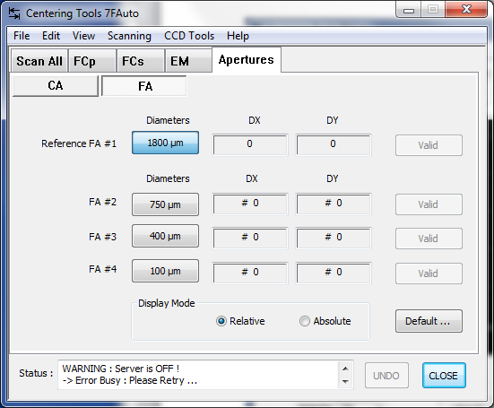

Two modes can be selected:

- Relative position: The relative position for each aperture, is the position ofset compare to the reference one. To store this values use the X and Y wheels, adjust position and valid it. The relative coordinate are stored in the setup file ‘cur_stpv3.set’.

# | Set-up Label | value
836 | FA#1DX | 0
837 | FA#1DY | 0
838 | FA#2DX | 99
839 | FA#2DY | 3535
840 | FA#3DX | 124
841 | FA#3DY | 7099
842 | FA#4DX | 243
843 | FA#4DY | 10723

- Absolute position: X and Y values are the real coordinates foe each aperture.
The absolute coordinate are stored in the setup file ‘cur_stpv3.set’.

# | Set-up Label | value
29 | FA#1 Dia(m) | 0.0018
30 | FA#2Dia(m) | 0.00075
31 | FA#3Dia(m) | 0.0004
32 | FA#14Dia(m) | 0.0001

Undo function allowed to recall old values from the setup file.

Contents ↑

